The International Space Station

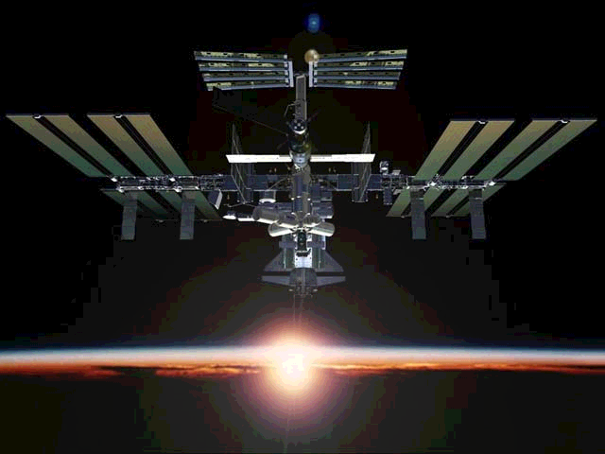

By: ???????????

???

International space station (ISS)

Background:
Despite the fact that ISS is not even finished yet, it has already got a long history. It all started in 1984 when the U.S. president Ronald Reagan committed the U.S. to develop a permanently occupied space station, named “Freedom”. Nasa invited other countries to join the project. In little more than a year after Nasa’s invitation, nine of the European Space Agency’s (ESA) 13 member countries, including Sweden, had signed on. Japan and Canada had also signed on.
In 1991, U.S. president George Bush and Russian president Mikhail Gorbachev agreed that the U.S. would work together with Russia on Mir (the Russian space station
In 1993 the U.S. president Bill Clinton directed Nasa to cut the costs. The engineers then made a whole new, simpler, design of the station. They made it smaller and more efficient. They also added more research resources and used the technology they had learned on Mir. They had now made it a lot less expensive and that brought Russia on board. Since it was now a whole new station, the station got a new name, “International space station”.

The station:
The first module, Zarya(Russian for “sunrise”) was launched in November 1998 from the Baikonur Cosmodrome in Kazakhstan. It was a Functional Cargo Block (FCB) and it is 43-fot tall and 20-ton heavy. FCB will be the main module and it will control the other modules and navigate the station if necessary. A month later “Unity” was launched. It is the part that links together the different parts of the station. Zvezda (Russian for "star") was launched on a Russian Proton rocket from the Baikonur Cosmodrome in July 2000. Zvezda serves as living quarters for the “Expedition One” crew (Commander Yuri Gidzenko, Commander Bill Shephard and Flight Engineer Sergei Krikalev) and provided early control of station. In September 2000 the space shuttle Atlantis successfully docked to the ISS. The Atlantis crew of five astronauts and two cosmonauts delivered more than 2,993 kg of supplies and installed batteries, power converters and the station's first toilet. Two astronauts made a six-hour space walk to connect power, data and communications cables between the newly arrived Zvezda Service Module and the station. The ISS currently weighs 112 tons and measures 52 meters in length. It will weigh about 453 tons when complete.
For now, the ISS-electric supply comes from an old Russian spacecraft, Progress, and Nasa’s space-shuttles. A Russian Sojuz spacecraft is also attached to the station to be used as a lifeboat. But it will soon be replaced by a new craft, an X-38 CRV (crew return vehicle). The X-38 CRV is about 28.5 feet tall and about 14.5 foot wide.
The station will orbit the Earth at the height of 220 miles and the orbit will lean 51.6 degrees to the equator. That is almost the exact same orbit as Mir. There are two reasons to why they have chosen that orbit. Since ISS is an international project they need an orbit that all the participants can reach from their launch-sites. It also gives a very good view of the Earth. You can see about 85% of the Earth and you also fly above 95% of the Earth’s population.

Goals:
Since a space station is very expensive, there must be a very good reason of building it. ISS is a world-class research centre in a unique environment. It will be used to find solutions to problems in medicine, ecology and other areas of science. It will also inspire young people to be interested in space science. ISS is also built to improve international co-operation and secure world peace.

Latest news:
The 10:th of February 2001 the U.S. built laboratory Destiny was successfully delivered and installed. The astronauts spent over 27 hours in four space walks, installing the new component.
The laboratory will be used in many areas including life science, microgravity science, Earth Science and space science research.

